Tail plane parameters

Table 1: Vertical tail data of passenger transport jet aircraft
Type | ² |  |  | L_{v}[ft] | 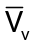
Boeing 727-200 | 1700 | 108 | 422 | 47.4 | 0.110
Boeing 737-200 | 980 | 93.0 | 233 | 40.7 | 0.100
Boeing 737-300 | 1117 | 94.8 | 239 | 45.7 | 0.100
Boeing 747-200B | 5500 | 196 | 830 | 102 | 0.079
Boeing 747SP | 5500 | 196 | 885 | 69.5 | 0.057
Boeing 757-200 | 1951 | 125 | 384 | 54.2 | 0.086
Boeing 767-200 | 3050 | 156 | 457 | 64.6 | 0.067
McDonnell Douglas DC-9-30 | 1270 | 108 | 168 | 50.5 | 0.062
McDonnell Douglas DC-9-50 | 1001 | 93.4 | 161 | 46.2 | 0.079
McDonnell Douglas DC-10-30 | 3958 | 165 | 605 | 64.6 | 0.060
Airbus A300B4 | 2799 | 147 | 487 | 79.5 | 0.094
Airbus A310 | 2357 | 144 | 487 | 68.5 | 0.098
Lockheed L1011-500 | 3541 | 164 | 550 | 58.2 | 0.035
Fokker F-28-4000 | 850 | 82.3 | 157 | 37.9 | 0.085
BAC 1-11 495 | 1031 | 93.5 | 117 | 31.6 | 0.038
BAe 146-200 | 832 | 86.4 | 224 | 38.9 | 0.120
Tupolev Tu-154 | 2169 | 123 | 841 | 43.3 | 0.055

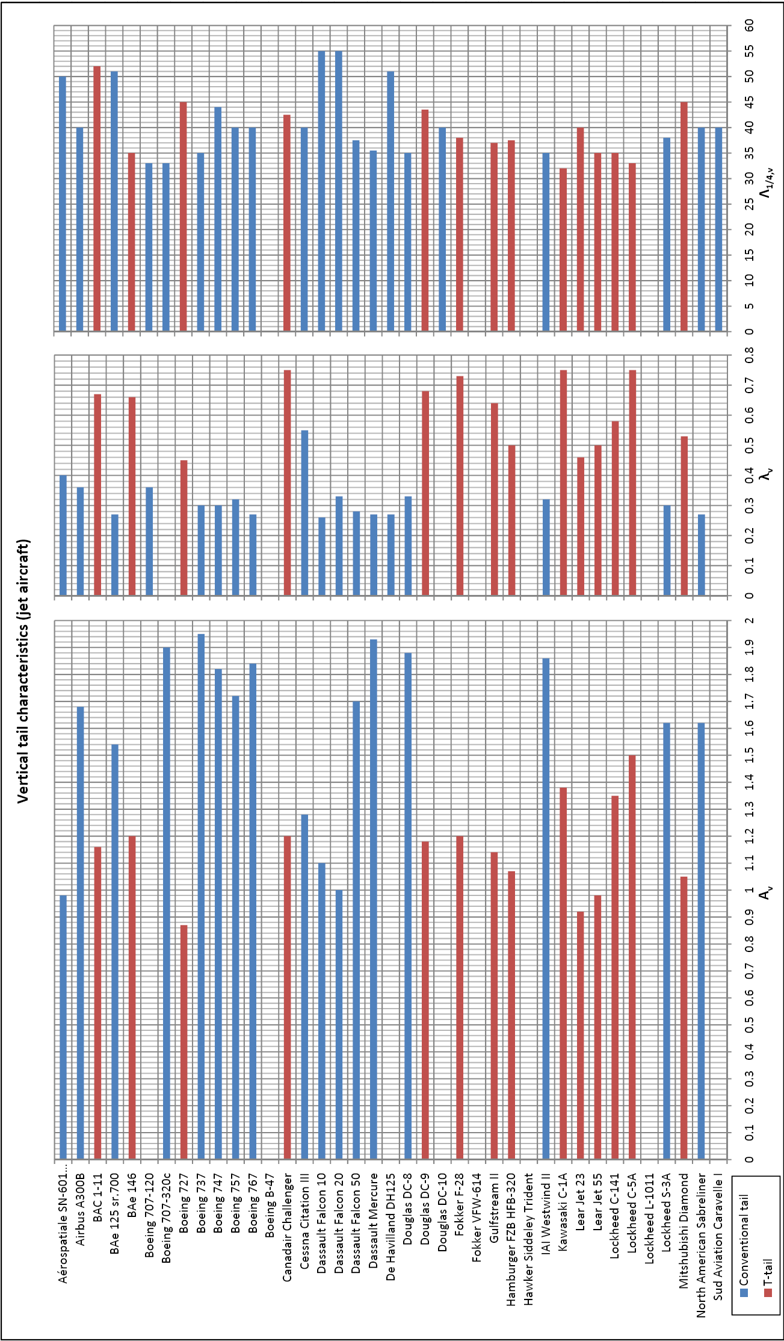
Figure.1: Vertical tail data jet aircraft

